User Manual ResearchConnect

2025

**Content**

Introduction 2

Creating Experiments 3

Creating Questionnaires 7

Creating Messages 18

Exporting data 23

Introduction  
This user guide explains the functionality of WildlifeNL's ResearchConnect application. It outlines the main features available in the application and provides step-by-step instructions for performing essential tasks. The manual includes tutorials for creating experiments, creating questionnaires, creating messages and exporting data.

# Creating Experiments

**To create an experiment, follow these steps. A visual example is provided on the next page with extra info:**  
1. Navigate to the **“My Experiments”** page, this can be done by clicking on the **Dashboard** button.

2. Click the **plus button (+)** in the bottom-right corner.

3. Fill in the required fields:

- **Experiment Title** (mandatory), only visible for researchers  
- **Description** (mandatory), only visible for researchers  
- **Start Date of the experiment** (mandatory), only visible for researchers  
- **End Date** **of the experiment** (optional), only visible for researchers  
- **Specific LivingLab** (optional), only visible for researchers

4. Click the **Submit Experiment** button in the bottom-right corner of the form.

5. The experiment is now created. It can be accessed from the **“My Experiments”** page by clicking on the newly created experiment in the table.

**Visualization**   
  
**1. Navigate to the “My Experiments” page, this can be done by clicking on the Dashboard button.**  
The Dashboard button is highlighted with a green circle in the image. The title "My Experiments" is shown inside the blue box.  
  
**2. Click the plus button (+) in the bottom-right corner**.

The plus button (+) is highlighted with a red arrow in the image.

**3. Fill in the required fields.**- **Experiment Title** (mandatory), only visible for researchers  
- **Description** (mandatory), only visible for researchers  
- **Start Date of the experiment** (mandatory), only visible for researchers  
- **End Date** **of the experiment** (optional), only visible for researchers  
- **Specific LivingLab** (optional), only visible for researchers  
  
**4. Click the Submit Experiment button in the bottom-right corner of the form.**

The submit button is highlighted with a red arrow in the image.

**5. The experiment is now created. It can be accessed from the “My Experiments” page by clicking on the newly created experiment in the table.  
  
**The experiment is highlighted with a red arrow in the image. It can be accessed by clicking and will bring you to the **”View for Experiment”** page.  **View for Experiment  
**

**Warning**: The **Stop Experiment** button is only functional when the experiment is live. Once the experiment has started, the **Delete Experiment** and **Edit Experiment** buttons will be disabled. Also **questionnaires** and **messages** can only be created, edited and deleted before the experiment goes live, the only way to stop it after going live is by using the **Stop Experiment** button.

# Creating Questionnaires

**To create a questionnaire, follow these steps. A visual example is provided on the next page with extra info:**1. Follow all steps of Creating Experiments described in the chapter before.

2. Navigate to the **”View for Experiment”** page for the experiment that requires the questionnaire.

3. Click on the **View Questionnaires** button. This will bring you to the **“Questionnaires for Experiment”** page

4. Click the **plus button (+)** in the bottom-right corner.

5. Fill in the required fields:

- **Name** (mandatory), visible for researchers & app users  
- **Internal Name** (optional), only visible for researchers  
- **Interaction Type** (mandatory), only visible for researchers  
  
6. Click the submit button in the bottom-right corner of the form.

7. The Questionnaire is now created. It can be accessed from the **“Questionnaires for Experiment”** page by clicking on the newly created questionnaire in the table. This will navigate towards the “**View for Questionnaire**” page.

8. Click the **plus button (+)** in the bottom-right corner.

9. Click the **plus button (+)** in the middle of the screen to add new questions.

10. Select between a Single Answer & Multiple Choice.

11. Fill in the required fields:

***Single Answer:***  
- Question name  
- Question description  
  
There is also the possibility to add a pattern.  
***Multiple Choice:***  
- **Question name** (mandatory)  
- **Question description** (mandatory)  
- **Each answer field** (mandatory)  
- **Allow multiple answers** (optional)  
- **Allow open answers** (optional)  
  
There is also the possibility to add a pattern.

12. Click the **submit button** in the bottom-right corner to save all questions when finished. This will navigate towards the “**View for Questionnaire**” page where the questions are visible.  
  
  
13. The questions are now created. It can be accessed from the **“View for Questionnaire”** page.

**Extra**  
  
The questions can be edited by clicking the edit button in the bottom-right corner of the “**View for Questionnaire**” page.

Messages can also be linked to multiple choice options by clicking on the message symbol of a question inthe **“View for Questionnaire”** page.  
  
**Visualization**  
  
**1. Follow all steps of Creating Experiments described in the chapter before.**An experiment has to be created before a questionnaire can be made.   
  
**2. Navigate to the ”View for Experiment” page for the experiment that requires the questionnaire.   
**

The experiment is highlighted with a red arrow in the image. It can be accessed by clicking and will bring you to the **”View for Experiment”** page.

**3. Click on the View Questionnaires button.

The View Questionnaires button is highlighted with a red arrow in the image. It can be accessed by clicking and will bring you to the **“Questionnaires for Experiment”** page.

**4. Click the plus button (+) in the bottom-right corner.**

The plus button (+) is highlighted with a red arrow in the image.

**5. Fill in the required fields:**

- **Name** (mandatory), visible for researchers & app users  
- **Internal Name** (optional), only visible for researchers  
- **Interaction Type** (mandatory), only visible for researchers  
  
**6. Click the submit button in the bottom-right corner of the form.**  
The submit button is highlighted with a red arrow in the image.

**7. The Questionnaire is now created. It can be accessed from the “Questionnaires for Experiment” page by clicking on the newly created questionnaire in the table. This will navigate towards the “View for Questionnaire” page.**

The questionnaire is highlighted with a red arrow in the image. It can be accessed by clicking and will bring you to the **”View for Questionnaire”** page.   
  
**8. Click the plus button (+) in the bottom-right corner.**

The plus button (+) is highlighted with a red arrow in the image.

**9. Click the plus button (+) in the middle of the screen to add new questions.  
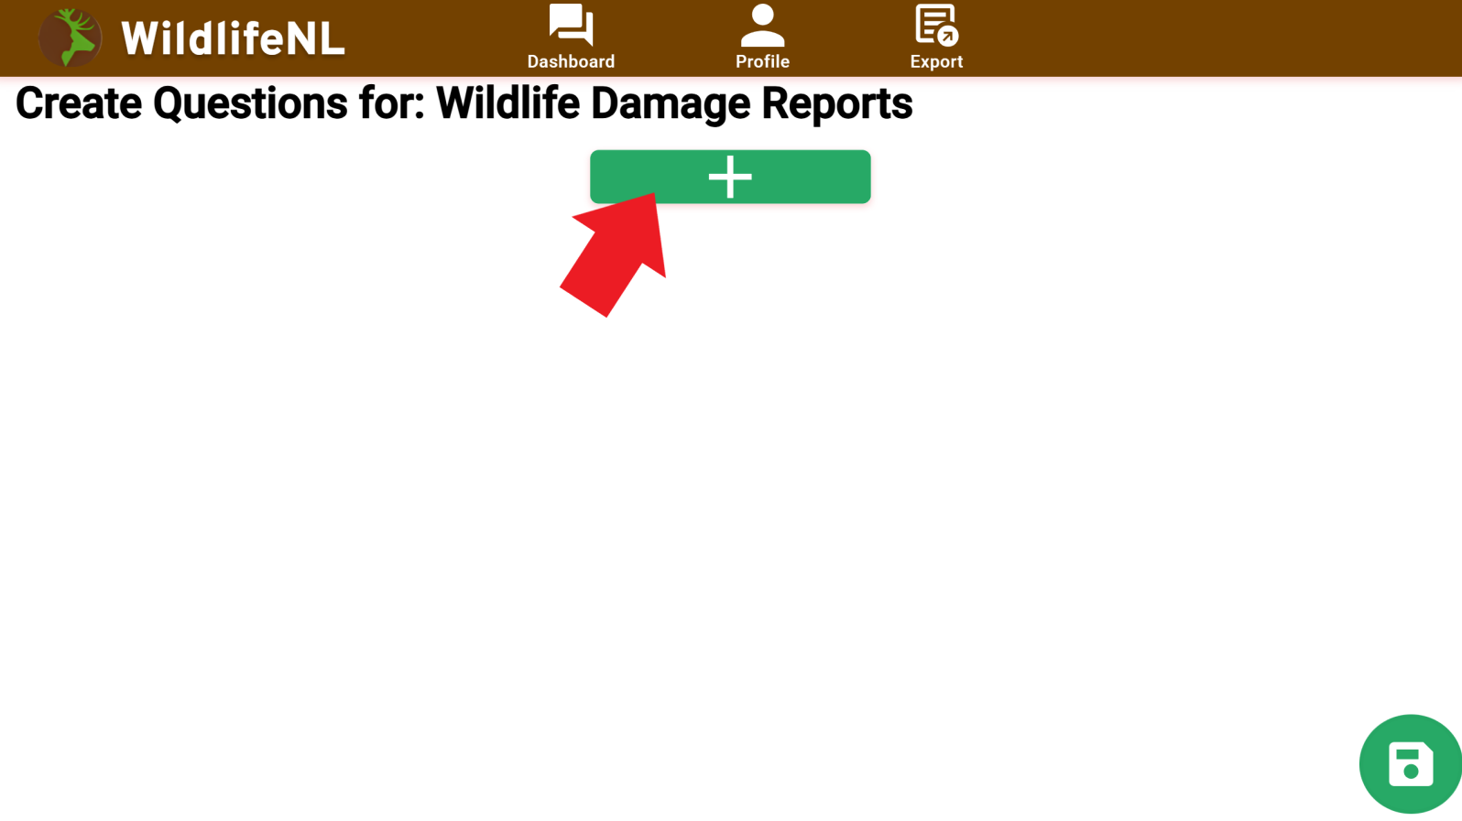**

The plus button [ + ] is highlighted with a red arrow in the image.

**10. Select between a Single Answer & Multiple Choice.   
**

**11. Fill in the required fields:**  
  
***Single Answer:***  
  
- **Question (mandatory)**, visible for researchers & app users  
- **Question description (mandatory)**, visible for researchers & app users  
  
There is also the possibility to add a pattern.  
***  
- **Question** (mandatory), visible for researchers & app users  
- **Question description** (mandatory), visible for researchers & app users  
- **Each answer field** (mandatory), visible for researchers & app users  
- **Allow multiple answers** (optional), visible for researchers & app users  
- **Allow open answers** (optional), visible for researchers & app users  
  
There is also the possibility to add a pattern.  
  
  
**Extra info**  
  
**The index of a question**   
The index of a question determines its position in the questionnaire. Questions are displayed in ascending order based on their index, with lower numbers appearing first. If multiple questions share the same index, they will be shown in a random order among themselves.  
**The index of answer options**  
****The index of an answer option determines its position within the multiple-choice question. Options are displayed in ascending order based on their index, with lower numbers appearing first. If multiple options share the same index, they will be shown in a random order among themselves.

**Follow up questions (multiple choice)   
**Follow-up questions can be accessed by clicking the green button with the arrow (highlighted in the blue box). Clicking this button opens a dropdown displaying all available questions with a higher index value, allowing you to select a relevant follow-up.

Follow-up questions make the questionnaire dynamic by skipping irrelevant questions based on user responses. When a follow-up condition is triggered, the questionnaire skips all questions with a lower index than the selected option and moves directly to the assigned question.

For example, if a user answers "No" to a key question, the system can immediately navigate them to the final section, bypassing any unnecessary intermediate questions.  
  
**12. Click the submit button in the bottom-right corner to save all questions when finished. This will navigate towards the “View for Questionnaire” page where the questions are visible.  
**

The submit button is highlighted with a red arrow in the image.

**13. The questions are now created. It can be accessed from the “View for Questionnaire” page.**  
  
 **Extra**  
  
**The questions can be edited by clicking the edit button in the bottom-right corner of the “View for Questionnaire” page.**  
The edit button is highlighted with a red arrow in the image.

**Messages can also be linked to multiple choice options by clicking on the message button of a multiple choice answer in “View for Questionnaire”  
  
**The message button is highlighted with a blue box in the image.  
  
- **Message Title** (mandatory), visible for researchers & app users  
- **Message Text** (mandatory), visible for researchers & app users  
- **Severity** (mandatory), only visible for researchers

# Creating Messages

**To create a message, follow these steps. A visual example is provided on the next page with extra info:**  
1. Follow all steps of Creating Experiments described in the experiment chapter.

2. Navigate to the **”View for Experiment”** page for the experiment that requires the message.

3. Click on the **View Messages** button. This will bring you to the **“Messages for Experiment”** page

4. Click the **plus button (+)** in the bottom-right corner.

5. Fill in the required fields:

**- Message Title** (mandatory), visible for researchers & app users **- Message Text** (mandatory), visible for researchers & app users **- Severity** (mandatory), only visible for researchers **- Specify Trigger** (mandatory), only visible for researchers  
- **The rest of the options dependent of the trigger** (mandatory), only visible for researchers  
6. Click the submit button in the bottom-right corner of the form.

7. The Questionnaire is now created. It can be accessed from the **“Messages for Experiment”** page by clicking on the newly created questionnaire in the table. This will navigate towards the “**View for Message**” page.

**Visualization  
  
1. Follow all steps of Creating Experiments described in the experiment chapter.**

**2. Navigate to the ”View for Experiment” page for the experiment that requires the message.**The experiment is highlighted with a red arrow in the image. It can be accessed by clicking and will bring you to the **”View for Experiment”** page.

**3. Click on the View Messages button. This will bring you to the “Messages for Experiment” page**

The View Messages button is highlighted with a red arrow in the image. It can be accessed by clicking and will bring you to the **“Messages for Experiment”** page.  
  
**4. Click the plus button (+) in the bottom-right corner.  
**

The plus button (+) is highlighted with a red arrow in the image.

**5. Fill in the required fields:  
**

**- Message Title** (mandatory), visible for researchers & app users **- Message Text** (mandatory), visible for researchers & app users **- Severity** (mandatory), only visible for researchers **- Speficy Trigger** (mandatory), only visible for researchers  
- **The rest of the options dependent on the chosen trigger** (mandatory), only visible for researchers **6. Click the submit button in the bottom-right corner of the form.  
**The submit button is highlighted with a red arrow in the image.

**7. The Message is now created. It can be accessed from the “Messages for Experiment” page by clicking on the newly created message in the table. This will navigate towards the “View for Message” page.  
  
**

The message is highlighted with a red arrow in the image. It can be accessed by clicking and will bring you to the **”Messages for Experiment”** page. **View for Experiment Afbeelding met tekst, schermopname, Lettertype, nummer
**

# Exporting data

**To export data, follow these steps. A visual example is provided on the next page with extra info:**

1. Navigate to the **“Export”** page, this can be done by clicking on the **Export** button in the navigation bar.  
  
2. Select the experiment that needs to be exported or click on the experiment for questionnaire specific export.   
  
3. Choose the desired export option.

4. Verify with the sample if it is the correct data.

5. Click the Download CSV button to download the data as **CSV.**

6. The data is now downloaded as a CSV.

**Visualization  
  
1. Navigate to the “Export” page, this can be done by clicking on the Export button in the navigation bar.**  
The Export button is highlighted with a red arrow in the image.

**2. Select the experiment that needs to be exported or click on the experiment for questionnaire specific export.**The Experiment is highlighted with a red arrow in the image. Clicking it will make the experiment expend and display its questionnaires.  
  
**3. Choose the desired export option.  
  
**

The Export Options Responses, Conveyances and Questionnaire Responses are shown inside the blue box. Click one of the buttons for a preview.  
  
**4. Verify with the sample if it is the correct data.**

**5. Click the Download CSV button to download the data as CSV.  
  
**

The Download CSV button is highlighted with a red arrow in the image.  
  
**6. The data is now downloaded as a CSV.  
  
**